3.63: a) The algebra is the same as that for Problem 3.58,
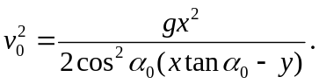
In this case, the value for y is 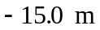, the change in height. Substitution of numerical values gives 17.8 m/s. b) 28.4 m from the near bank (i.e., in the water!).

